Guided Lab - 303.1.2B

How to Run Java Programs in IntelliJ Ultimate

Introduction:
In this lab, we will demonstrate how to run Java programs using IntelliJ Ultimate.

Lab Objective:
By the end of this lab, learners should be able to run a Java program using IntelliJ Ultimate.

Instructions
For this lab, you must have IntelliJ Ultimate pre-installed on your computer. Download IntelliJ here IntelliJ download.

1. Open IntelliJ Ultimate and click on New project.
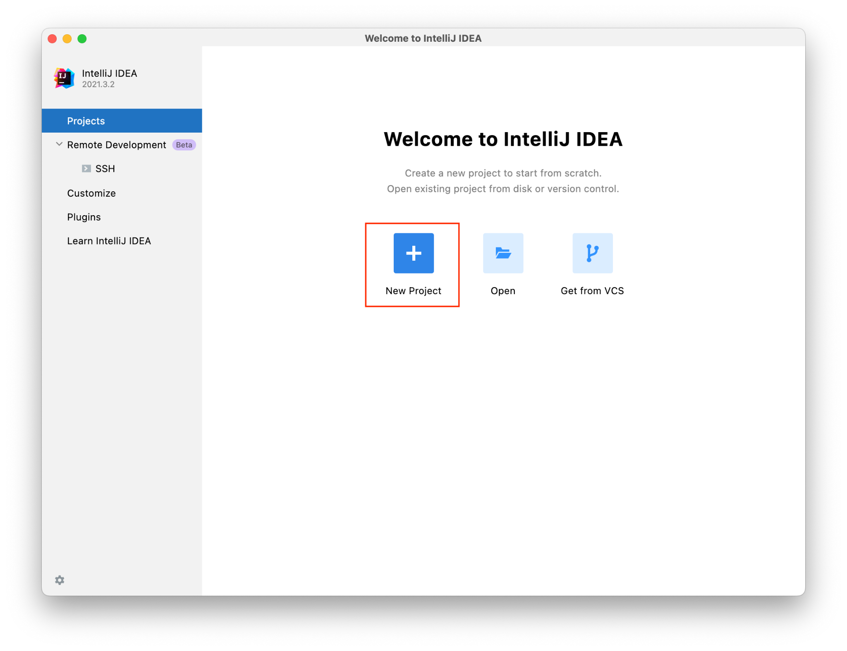

2. Go to the JDK section and click on the dropdown bar. Next click on Download JDK.
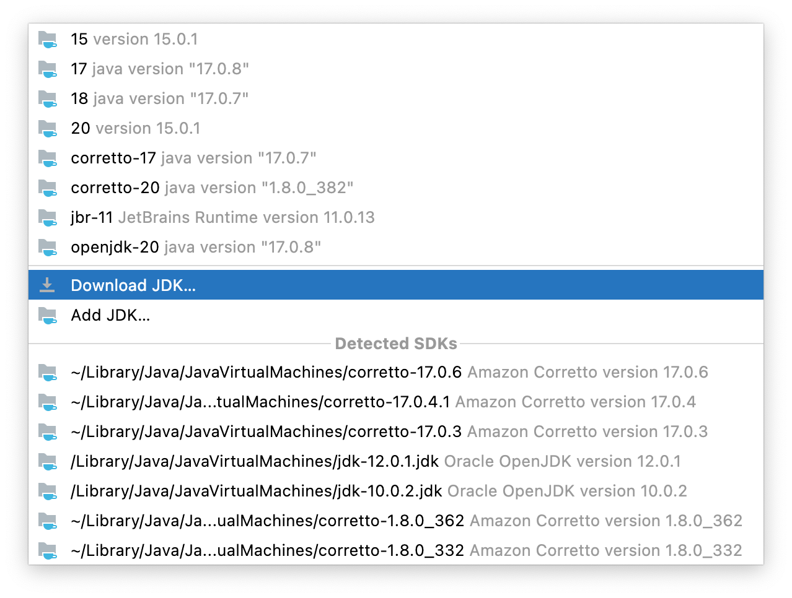
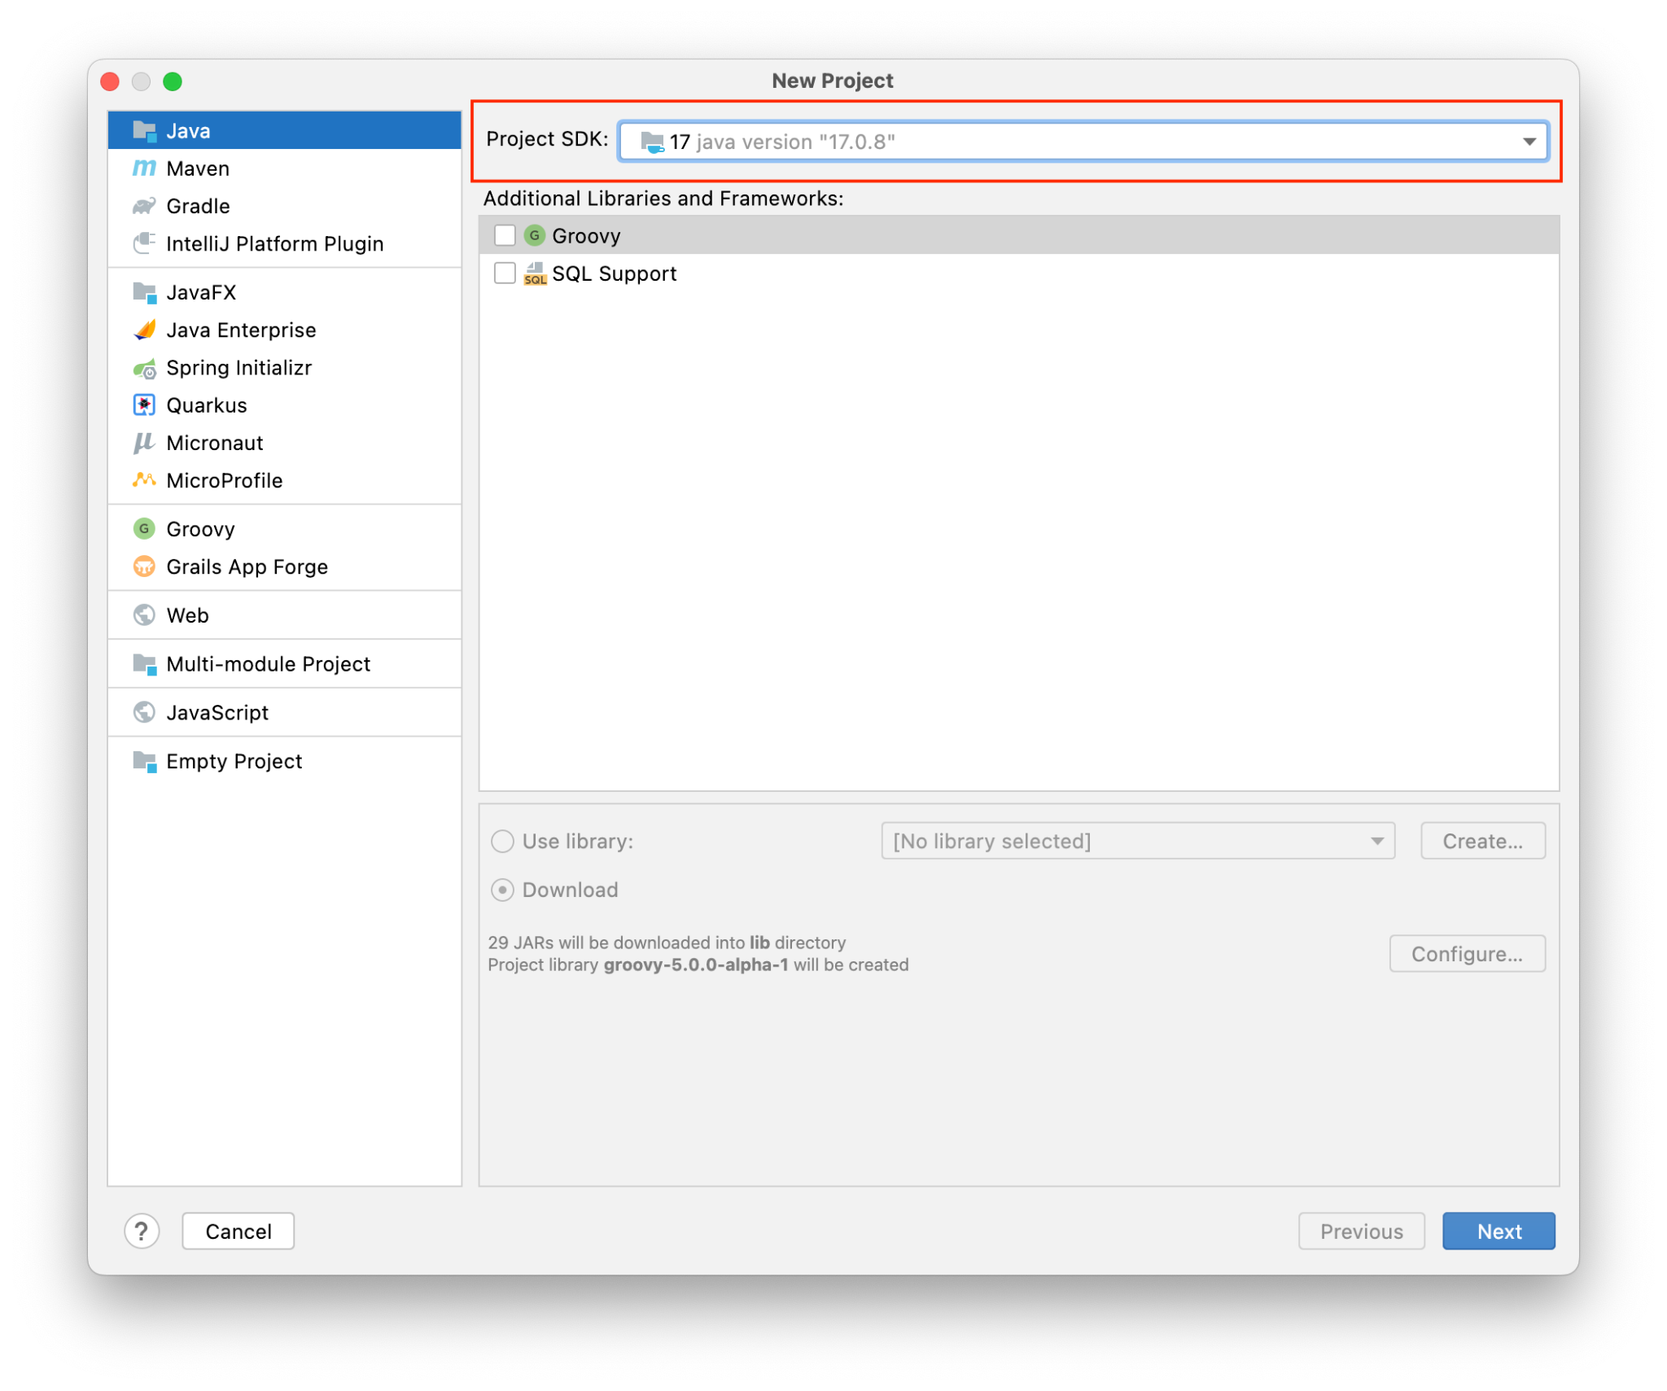

3. Go to the vendor dropdown menu and click on Amazon Coretto. After downloading the appropriate version, click Next at the bottom right-hand corner.
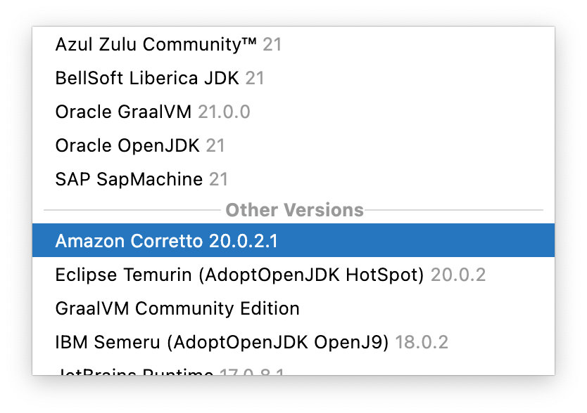
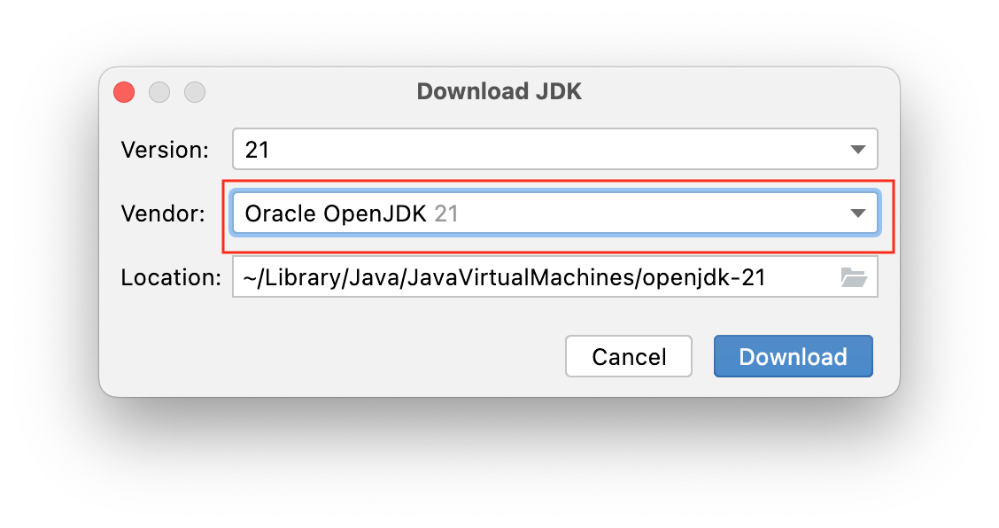

4. Click on the (Create project from template) checkbox.
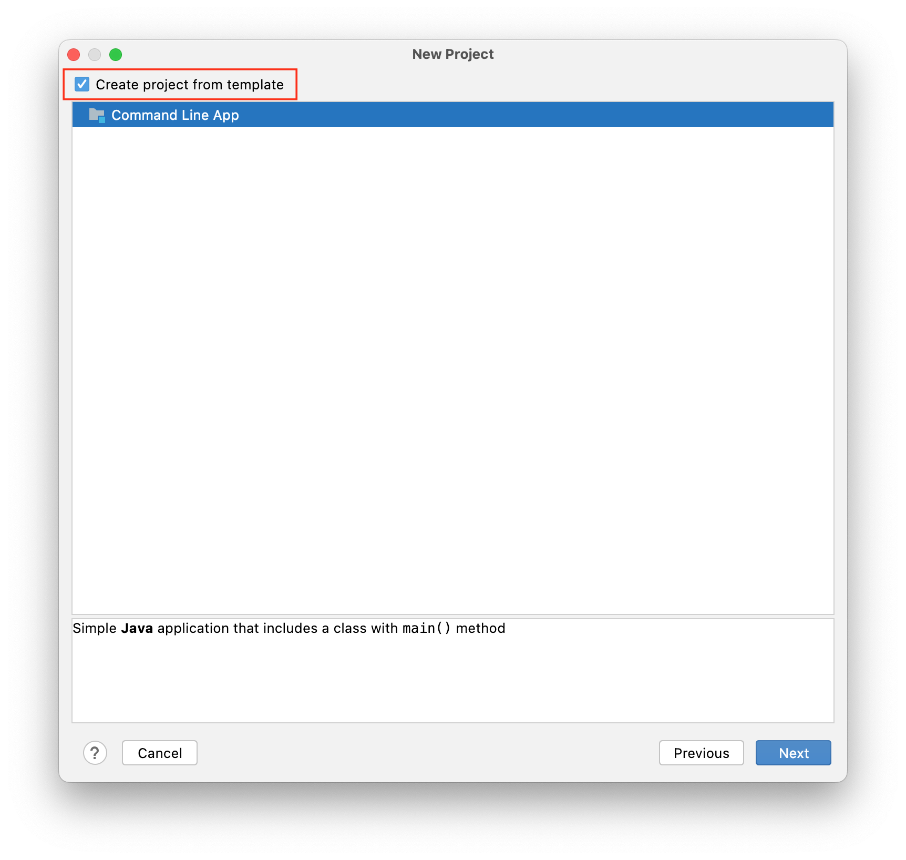

5. Name your new project.
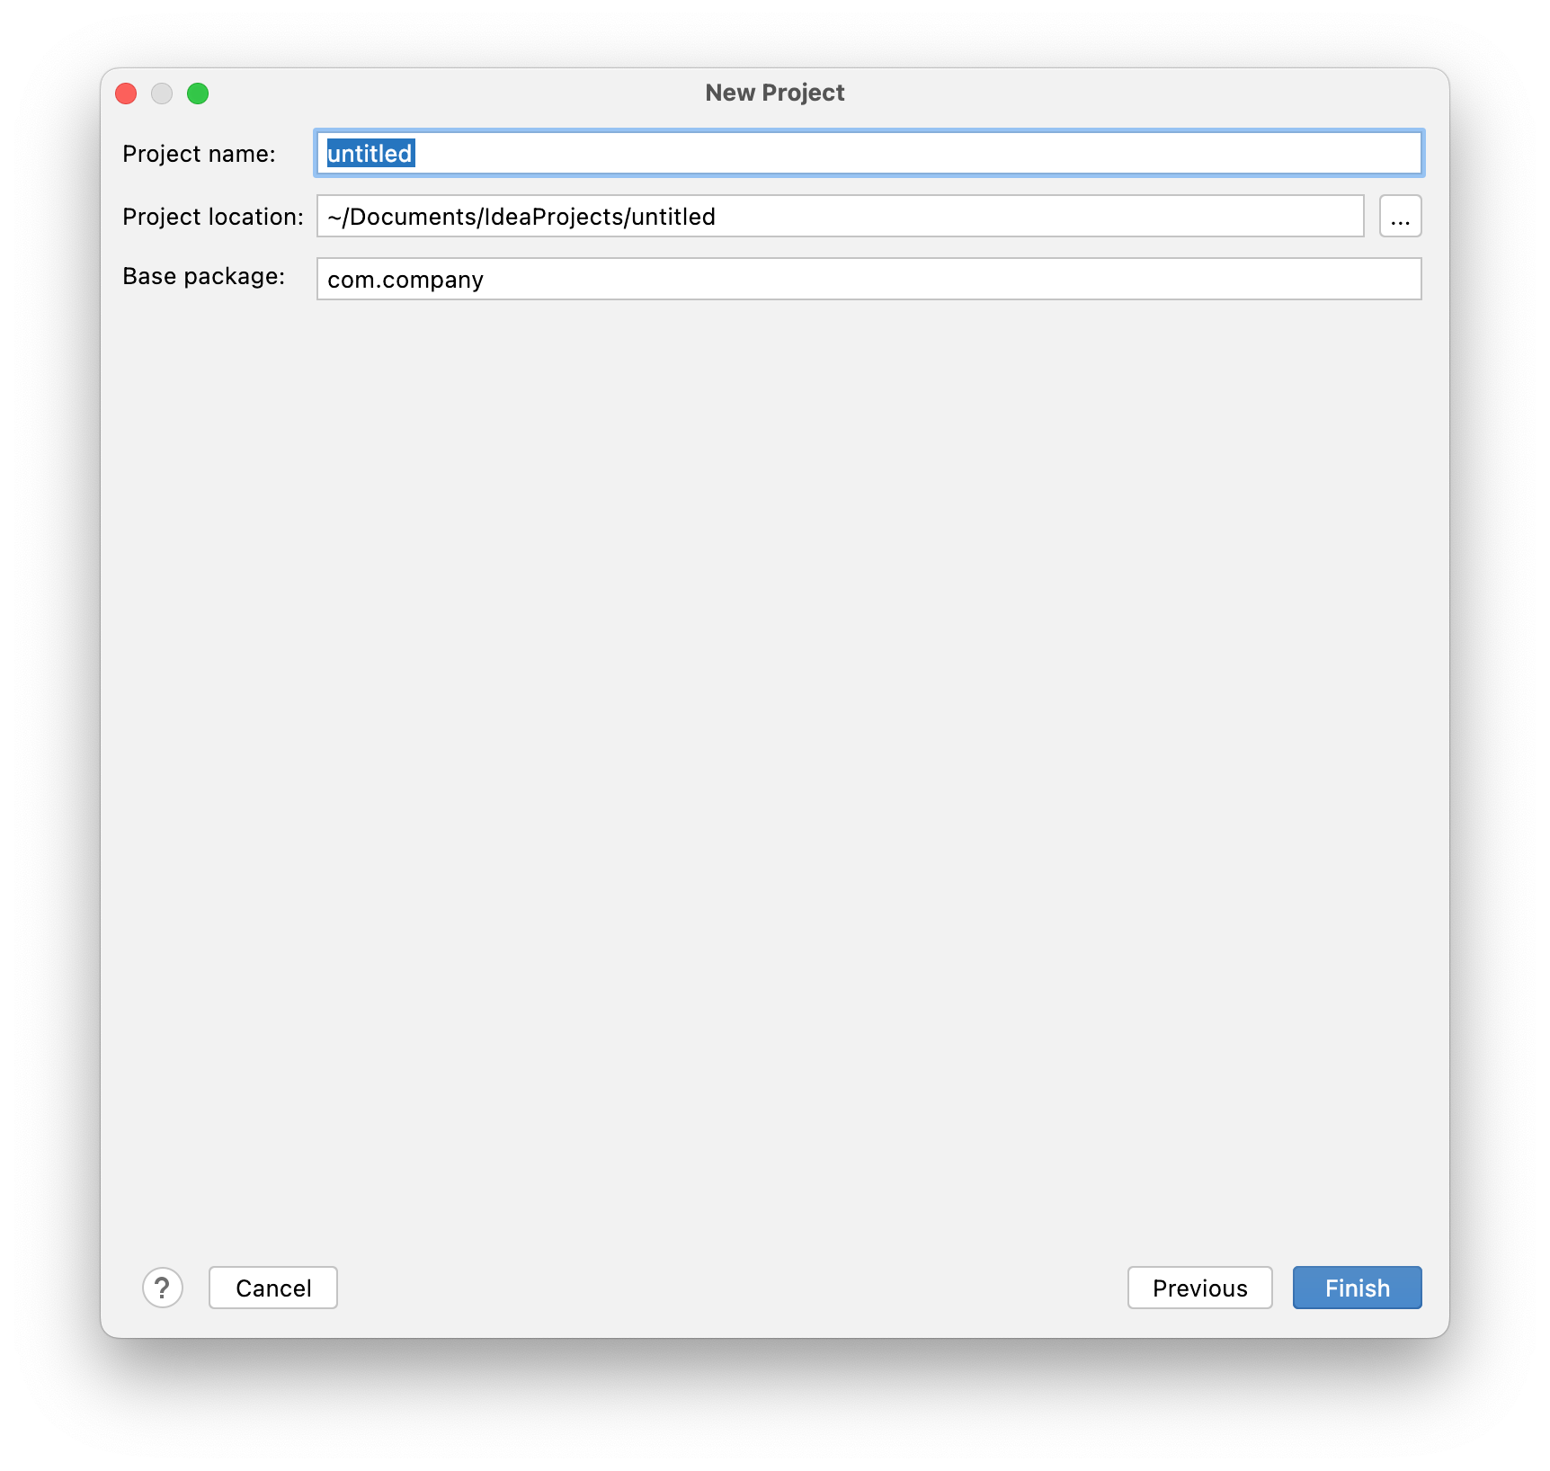

6. To run a program in IntelliJ, click on the green Play icon in the top-right or left corner, depending on your version and layout. You may see the Main or Current file depending on your version.



7. Output
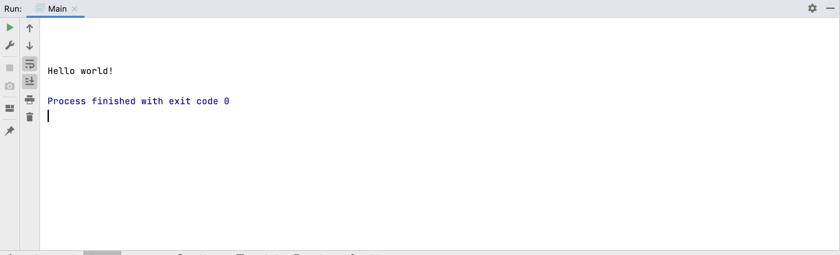

Submission Instructions:
Submission Instructions:
Include the following deliverables in your submission -
  - Submit your screenshot using the Start Assignment button in the top right corner of the assignment page in Canvas.
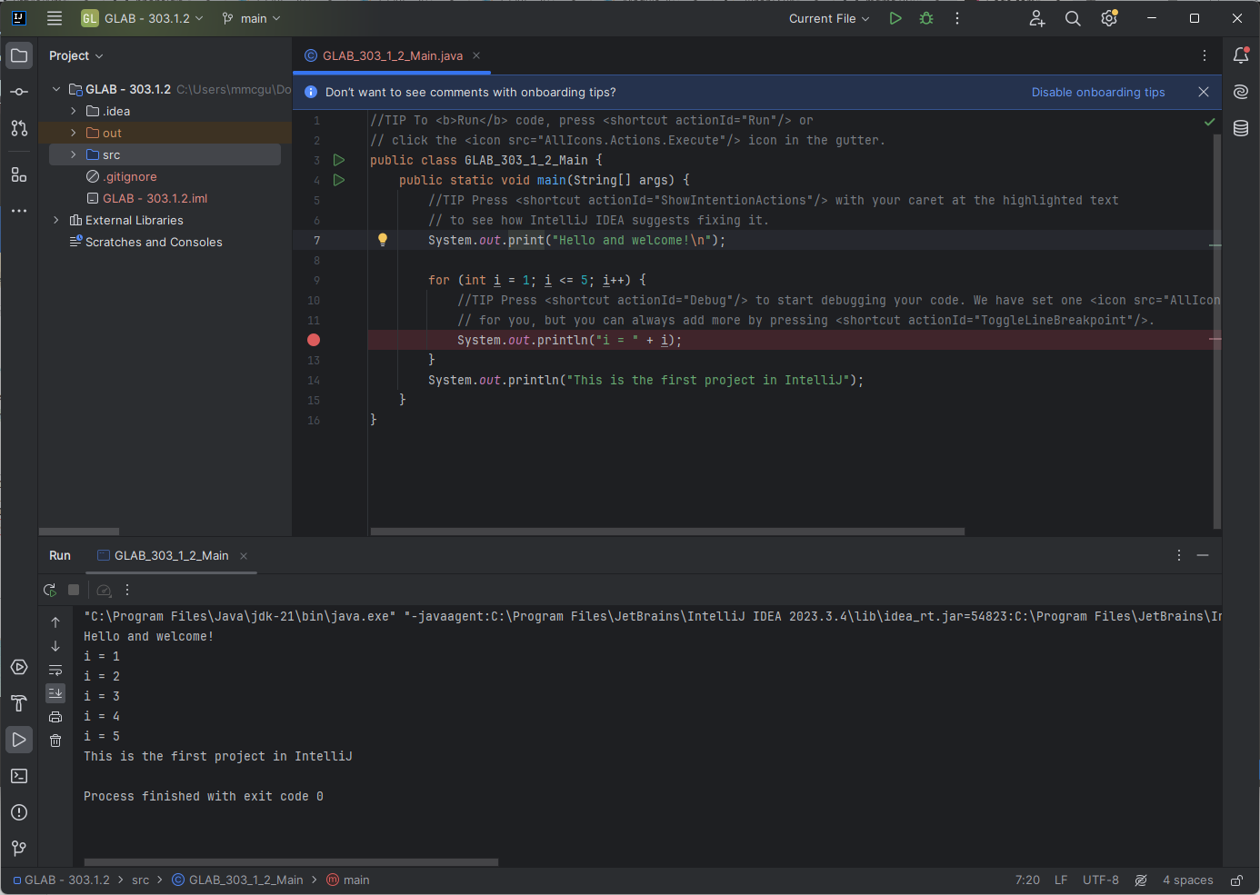
Above is a screenshot of a running Java Project in IntelliJ
CANVAS STAFF USE ONLY: Canvas Submission Guideline:
Instructions for Canvas Assignment Creation
Assignment Name: GLAB - 303.1.2- How to Run Java Program in IntelliJ Ultimate
Points: 100
Assignment Group: Module 303: Java SE Review (Not Graded)
Display Grade As: Complete/Incomplete
Do not count this assignment towards the final grade: Checked
Submission Types: File Uploads

Everything else is the default.

